Title: Must be informative and revealing
(.docx file -MSWord- is required)

Author1 (1), Author2 (2), Author3 (2)

(1) Author address. Email address. Myriad Pro 8 pts-size.
(2) Departamento de Geología, Facultad de Ciencias Físicas y Matemáticas, Universidad de Chile. geaston@uchile.cl

Abstract: We suggest that the abstract includes a brief location and context, the objective of the work and the most relevant conclusion (maximum length: 150 words). Myriad pro font style, 9 pts, italic, and single space between lines. If you don’t have Myriad Pro, use Times New Roman instead.

Key words: 5 words maximum. Myriad Pro 8 pts-size.

FORMATTING OF EXTENDED ABSTRACT

This is an example of the final publication format for extended abstracts that will be published online in the proceedings of the 12th International INQUA Meeting on Paleoseismology, Active Tectonics and Archaeoseismology (PATA), October 6th-11th, 2024, Los Andes, Chile.

Authors should use this example paper, and all the general formatting: letter-size Myriad Pro 9 points and single space among lines (if you don’t have Myriad Pro, please use Times New Roman instead), 2-columns, embedded figures (e.g. Fig. 1), included-sections, headers, footers, and frames, to create a similar-looking document. You may need to include a figure using the entire width of the page; please do it by inserting a section break.

The following items are required: Header, Title, Authors, Addresses, Abstract, Introduction, Methods (if necessary), Results/Discussion, Conclusions, Acknowledgements, and References.

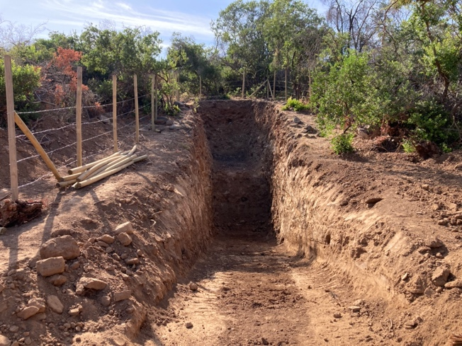
Fig. 1: Captions appear related with the figures and with 8 pts. sized. All figures must be referred in the main text.

The communication length will be as far as 4 pages.
Figures should be clearly readable, for the reviewers, 300 dpi resolution is suggested. Authors should have the full-resolution figures available, if requested by editors. If authors use figures that are copyrighted, then they must obtain written permission from the copyright holder to use the figure. Authors will be required to sign a copyright release statement saying that they have acquired this permission.

Citations and references: If authors are cited directly (e.g., Valverde (2005) says….), then also use the formats of Valverde & Pereiro (2006) and Valverde et al. (1998). If the papers are cited (e.g. …from offshore studies (Reid, 1997), then also use the formats of (Rio & Hernandez, 2004) and (Riera et al., 2011). See the reference section of this draft for examples on the format and style that should be used for the references (i.e., the AGU format). The reference list will be classified by alphabetic name and year of publication.

Acknowledgements: Brief words given thanks to projects and supporters. Font style: Myriad Pro 8 pts.

References
Silva, P.G., M.A Rodríguez-Pascua, R. Pérez-López, J.L. Giner-Robles, J. Lario, T. Bardají, J.L. Goy & C. Zazo, (2009). Geological and archaeological record of the 1504 AD Carmona earthquake (Guadalquivir Basin, South Spain): a review after Bonsor, 1918. In: Archaeoseismology and Palaeoseismology in the Alpine-Himalayan Collisional Zone (Pérez-López, R., Grützner, C., Lario, J., Reicherter, K., Silva, P.G. eds). Baelo Claudia, Spain, 139-142.
Hinzen, K.-G., S. Schreiber & B. Yerli, (2010). The Lycian Sarcophagus of Arttumpara, Pinara (Turkey) -Testing Seismogenic and Anthropogenic Damage Scenarios. Bulletin of the Seismological Society of America 100 (6), 3148-3164.
Nur, A., Burgess, D. (2008). Apocalypse: Earthquakes, Archaeology and the Wrath of God. Princeton University Press. Princeton and Oxford. 309 p.

